

PROJECT REPORT
ON
LOST AND FOUND TRACKER
Degree of Bachelor of Technology
In
Computer Science and Engineering (AIML)
By

NAME :- TANISHKA JOSHI
REGISTRATION NUMBER :- 25BAI10767
INTRODUCTION

In our college, students often lose their belongings like ID cards, notebooks, earphones, bottles, calculators and many other items. Most of the time these things are found by someone, but the owner and the finder don’t know how to contact each other. Usually, people just send messages in WhatsApp groups, which get ignored or lost in other chats.

Seeing this problem, I decided to create a simple Lost and Found Tracker using Python.
The idea is to have one small system where anyone can record what they lost or what they found. This makes it easier to match items and return them to the right owner. The project is simple, but it helps create a more organized way of handling lost and found items inside the campus.
PROBLEM STATEMENT

There is no proper system in the college to manage lost and found items. Students depend on random announcements, class group chats, or word of mouth. Because of this, many items never get returned to the owner. Messages get buried, people forget, and there is no central place to check.

So, there is a need for a basic system where lost and found details can be stored, searched and viewed easily. The aim is to reduce confusion and help students get their belongings back faster.

FUNCTIONAL REQUIREMENT

These are the things the system should be able to :-

1. Allow users to add details of lost items.

2. Allow users to add details of found items.

3. Store all the information in lists or dictionaries.

4. Let the user search for an item by entering its name.

5. Show a list of all lost items.

6. Show a list of all found items.

7. Give the option to exit the system.

These functions cover the basic needs of the lost and found process.
NON FUNCTIONAL REQUIREMENT

These describe the quality of the system:

1. Easy to Use: The system should be simple enough for any student to operate.

2. Reliable: Data should stay correct while the program is running.

3. Fast: Searching items should be quick it.

4. Portable: The program should run on any computer that has Python installed.

5. Maintainable: The code should be clean so that improvements can be made later.

6. Scalable: More items can be added without slowing it down.

ALGORITHM
1. Start the program
2. Create two empty lists: lost and found
3. Display the menu with 6 options
4. Ask the user to enter their choice
5. If user chooses option 1:
Take lost item details
Store in lost list
6. If user chooses option 2:
Take found item details
Store in found list
7. If user chooses option 3:
Display all lost items
8. If user chooses option 4:
Display all found items
9. If user chooses option 5:
Compare both lists
Show matched items
10. If user chooses option 6:
Exit the program
11. If invalid choice, show error
12. Repeat steps 3–11
13. End
FLOW CHART
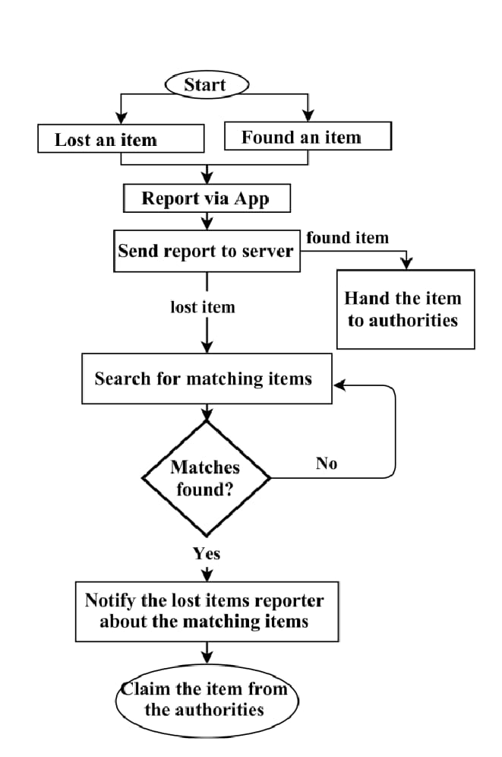

UPPPER CASE DIAGRAM

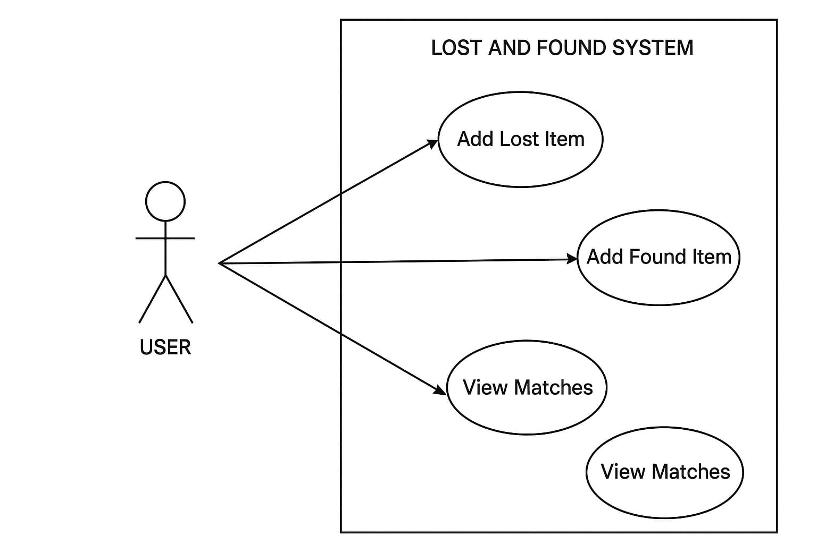
WORK FLOW DIAGRAM 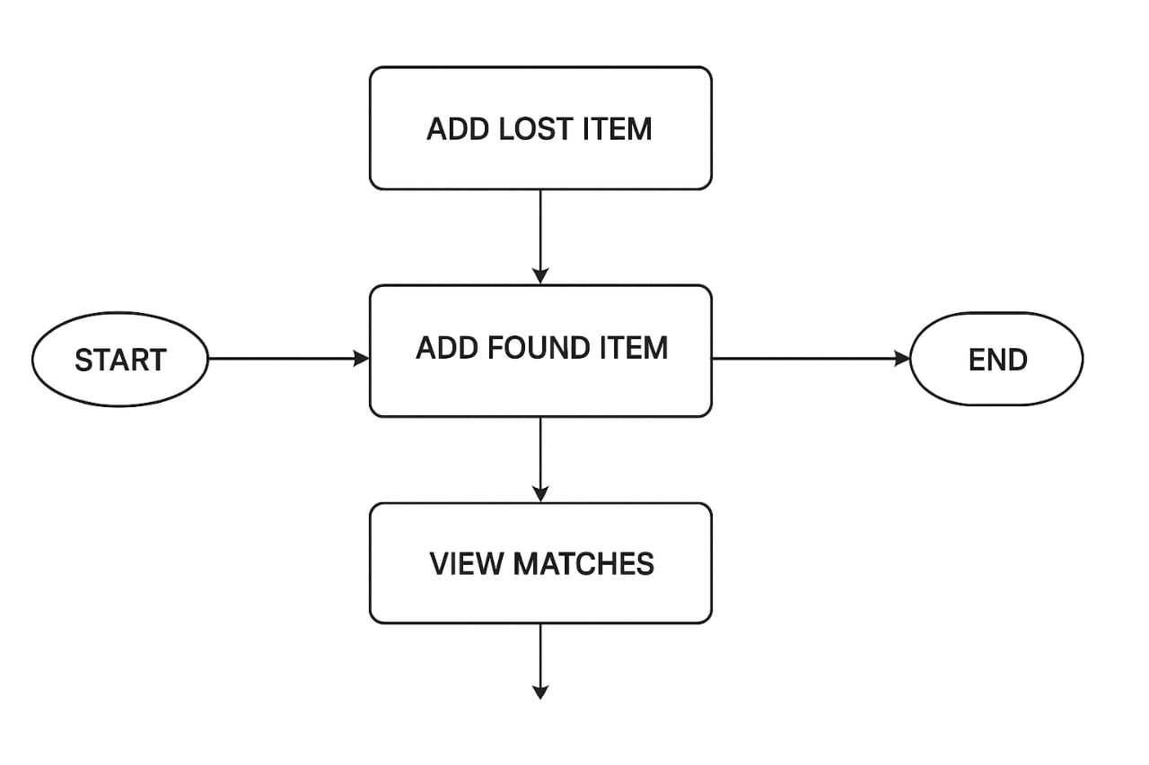
OUTPUT

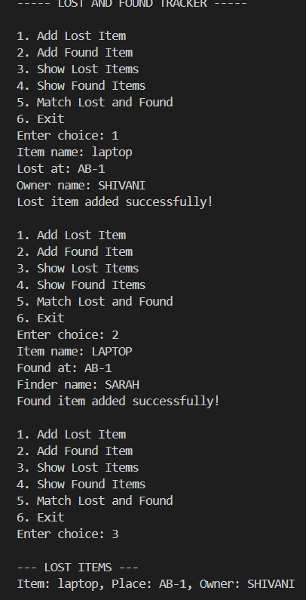

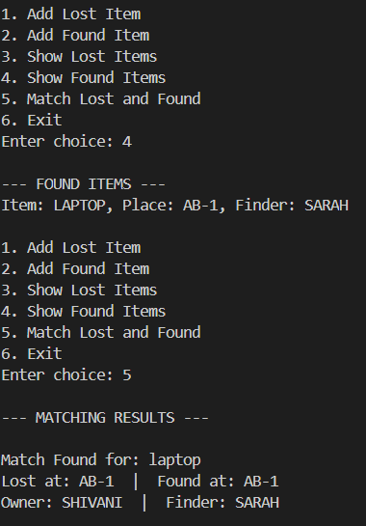

FUTURE ENHANCEMENTS

- Adding login system

- Adding item images

- Adding timestamps

- Converting into web/app

- Automatic notifications

CONCLUSION
The Lost and Found Tracker successfully solves the common problem of misplaced items by providing a simple and user-friendly digital solution. The system efficiently stores lost and found items and helps match them automatically. Through this project, I learned how Python can be used to build real applications using lists, dictionaries, loops, and conditionals. The project is small but meaningful and can be upgraded into

